In this project, you created a complete soundscape for a waterfall environment. In doing so, you learned about the key features of an Audio Source and how to configure both ambient and event based audio effects. You also further customized the scene by adding a reverb zone to create an echoing effect. In this final challenge, you’ll take everything that you’ve learned and create a soundscape for a new environment.
As you prepare to create your own soundscape, let’s hear from our creators about some of the challenges you might encounter when designing audio for an experience:
Play Video
Mark step complete
2. Create your soundscape
Q&A (0)
1. In the Scenes folder, locate and open Audio_Indoor_Scene.
2. Explore the scene in Play mode.
3. Identify several items that you can audio effects to. Remember that not all audio sources need to be visible.
4. Consider what kind of narrative you wish your soundscape to present to the user.
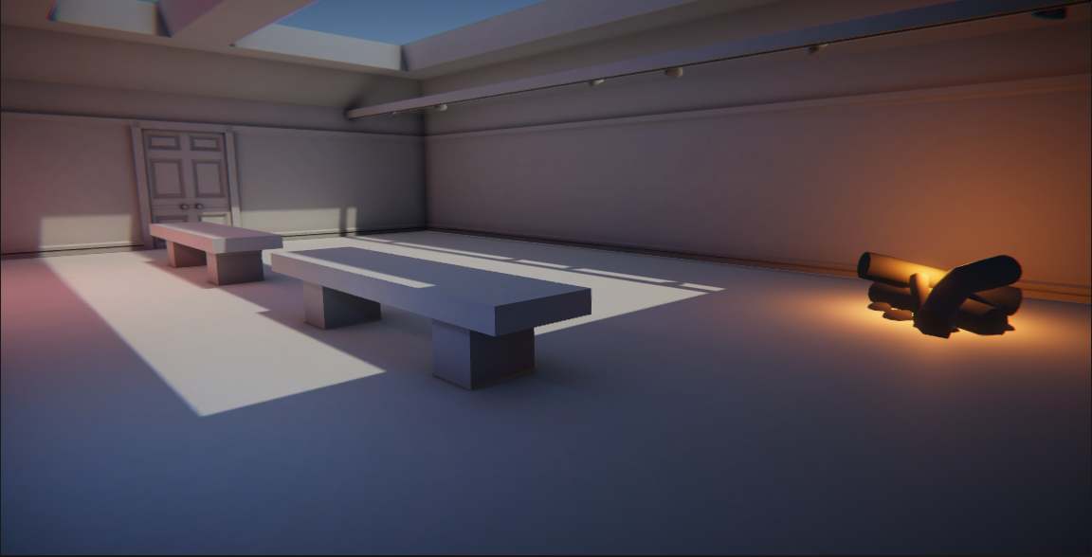
This base scene is just a starting point: you may add anything you like to the environment, but nothing can be removed! To complete this challenge, you must assess the environment and determine what kind of sound effects it should have, find those sound effects, and then apply them in Unity. As you work through the development process, remember:
- What ambient sounds would make sense for this environment? Remember, even a silent room is rarely truly silent.
- What objects in the environment would be making sounds?
- What types of materials are the environment’s elements made of? Would they produce echoes? Would they absorb sounds?
Gather your audio effects, taking care to make note of the license type for each sound. Ideally, you should use audio that has a CC0 license, but if you need to credit the creators, you can keep a text file in your Unity project with all of the required credits listed. This can also be a good opportunity to create sound effects yourself!
​​You should expect to spend at least 40 minutes on this challenge.
Mark step complete
3. Criteria
Q&A (0)
You’ll know you’re successful if you’ve met these criteria:
- You’ve added no fewer than five audio effects.
- You have sources representing ambient sounds.
- You have audio sources representing direct objects in the scene.
- You’ve added at least one special effect for an audio source.
Mark step complete
4. Next steps
Q&A (0)
Congratulations! You have completed the learning required for Core Audio.
You have the core skills and knowledge for one of the primary creative domains within the Unity Engine.
Now you’re ready to apply these skills in other projects! We can’t wait to see what you make next.
Mark step complete
Optional step
5. Submit your project
Q&A (0)
When you’ve completed this challenge, please submit and share your project. This isn’t a requirement for completing this mission but it’s a great opportunity to share your progress and learn from the work of others.
To submit your project:
1. Review the specific guidance for this challenge (above) and check your project to make sure that you have achieved the challenge criteria. Remember, there’s no deadline on submissions; you can take the time that you need to do this.
2. Create and publish a WebGL build of your project. You can publish your submission on Unity Play or other third-party hosting platforms.
3. Add the link to your hosted WebGL build to the submission form at the bottom of this step.
4. Add a submission title and description. If you have additional details to share about your process or the project that you have created, you can share them in the description.
5. Set who can view your submission:
- Public: Anyone who views this tutorial.
- Private: Just you.
6. Select Save and preview submission.
7. Check your submission preview and then complete the CAPTCHA test and select Submit and continue.

